AIML LAB FILE

Submitted By:
Name:Anmol Thapliyal
SAP ID:590011794
Batch-36
Branch: B.Tech CSE

Submitted To:
Faculty Name:Prof. Sumit Singh
Department: Computer Science & Engineering

INDEX:

Exp No. | Experiment Title
1 | KNN Missing Value Prediction
2 | Basic Data Analysis & Encoding
3 | KNN Classification using Sklearn
4 | K-Means Clustering (Manual Implementation)
5 | Linear Regression Without Sklearn
6 | Linear Regression Using Sklearn
7 | Matplotlib Graphs & Visualization
8 | Exploratory Data Analysis (EDA)
9 | Outlier Detection using Z-Score
10 | One-Hot Encoding & List Mapping
11.1 | PCA Using Sklearn
11.2 | PCA Without Sklearn
12 | Logistic Regression for Fraud Detection

EXP:1- KNN Missing Value Prediction
import pandas as pd

df=pd.read_excel("e:/sem 3/aiml lab/data.xlsx")
print("Dataset:\n",df)

a=df[df["Class"].isnull()].iloc[0]
b=df[df["Class"].notnull()]

b["Dist"]=((b["Height"]-a["Height"])**2+(b["Weight"]-a["Weight"])**2 )**0.5

sorted=b.sort_values("Dist")

k=3
neighbors=sorted.head(k)

prob=neighbors["Class"].mode()[0]
print("\nNearest neighbors:\n", neighbors[["Height","Weight","Class","Dist"]])
print("\nPredicted Class for missing row:",prob)
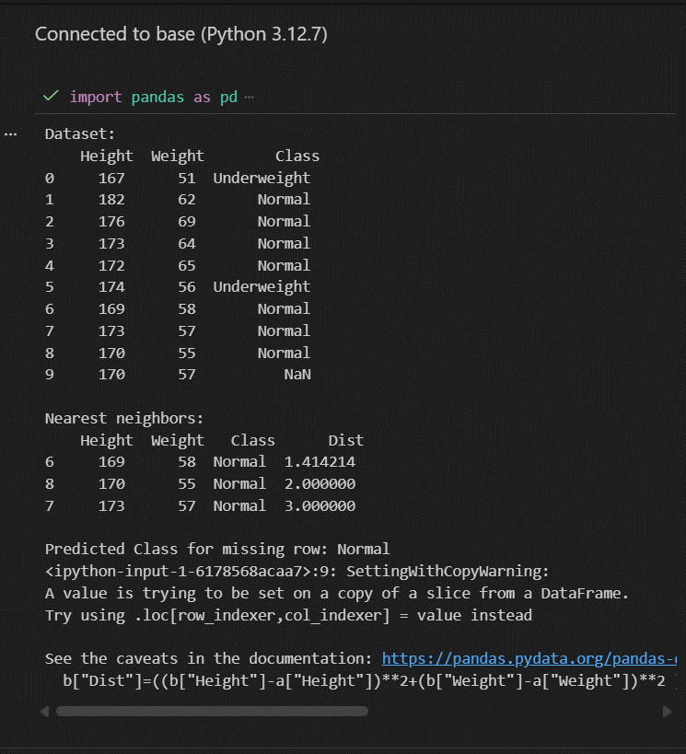

EXP:2- Basic Data Analysis & Encoding
import pandas as pd

d={"wt":[60,None,70,80,90,40],
"ht":[170,180,190,None,160,165],
"cl":["Normal","overweight",None,"Underweight",None,"Normal"]}

df=pd.DataFrame(d)

print("Rows:",df.shape[0])
print("Cols:",df.shape[1])
print("\nHead:\n",df.head())
print("\nSize:",df.size)
print("\nMissing:\n",df.isnull().sum())

n=df.select_dtypes(include='number')
print("\nSum:\n",n.sum())
print("\nAvg:\n",n.mean())
print("\nMin:\n",n.min())
print("\nMax:\n",n.max())

m={"Normal":"N","overweight":"O","Underweight":"U"}
df['cl'] = df['cl'].map(m).fillna("Ukn")

feat=df[['wt','ht']].values.tolist()
label=df['cl'].tolist()

print("\nFeatures:",feat)
print("Labels:",label)

df.to_csv("exp.csv")
print("\nExported to exp.csv")

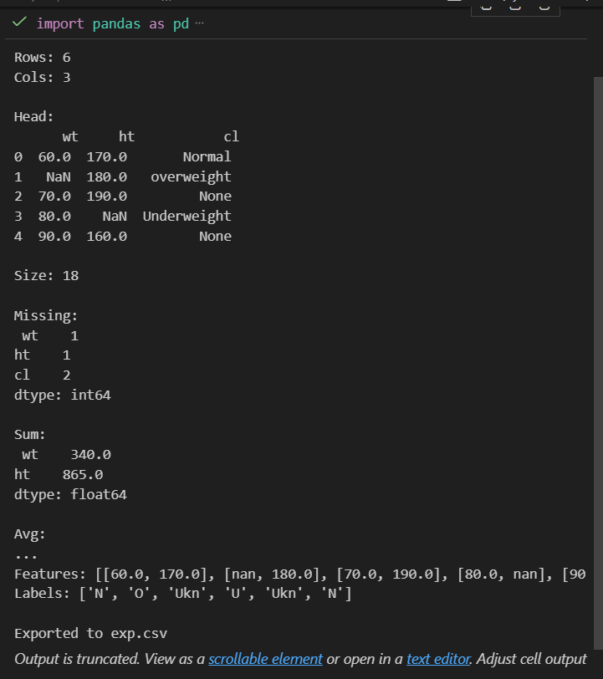

EXP:3- KNN Classification (sklearn)
import pandas as pd
from sklearn.neighbors import KNeighborsClassifier

df=pd.read_excel("e:/sem 3/aiml lab/data.xlsx")
print("Dataset:\n",df)

t1=df[df["Class"].notnull()]
t2=df[df["Class"].isnull()]

x=t1[["Height","Weight"]]
y=t1["Class"]

neigh=KNeighborsClassifier(n_neighbors=5)
neigh.fit(x,y)

pred=neigh.predict(t2[["Height","Weight"]])
prob=neigh.predict_proba(t2[["Height","Weight"]])

print("\nTest rows:\n",t2[["Height","Weight"]])
print("\nPredicted Class:",pred)
print("Probabilities:\n",prob)

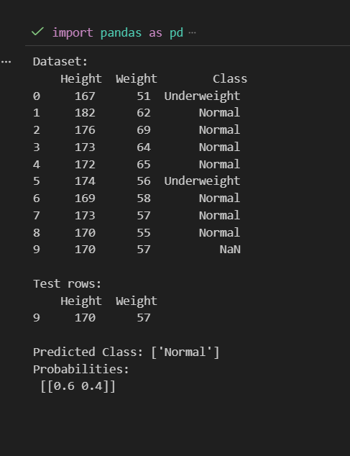
EXP:4- K-Means Clustering (Manual)
# K-Means Clustering without sklearn
import pandas as pd
import numpy as np
import random
random.seed(69)
df=pd.read_excel("e:/sem 3/aiml lab/cluster_data.xlsx")
print("Dataset:\n",df)
x=df[["dim1","dim2"]].values
def kmeans(x,k,i=100):
c=x[random.sample(range(len(x)),k)]
for _ in range(i):
l=[]
for p in x:
dists=[]
for ci in c:
d=((p[0]-ci[0])**2+(p[1]-ci[1])**2)**0.5
dists.append(d)
min_idx=0
for j in range(1,len(dists)):
if dists[j] < dists[min_idx]:
min_idx=j
l.append(min_idx)
nc=[]
for j in range(k):
pts=[x[m] for m in range(len(x)) if l[m]==j]
if pts:
nc.append(np.mean(pts,axis=0))
else:
nc.append(c[j])
if np.allclose(c,nc):
break
c=nc
return c,l
k=5
centers,labels=kmeans(x,k)
df["Cluster"]=[l+1 for l in labels]
print("\nCluster Centers:\n",centers)
print("\nClustered Dataset:\n",df)
df.to_csv("clustered_data.csv")
print("\nExported to clustered_data.csv")

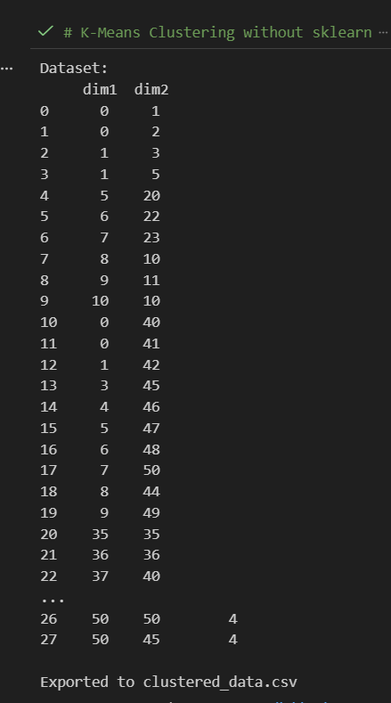

EXP:5- Linear Regression Without Sklearn
#liner regression without sklearn
import numpy as np
import matplotlib.pyplot as plt

x=np.array([35,45,50,65,70,75],dtype=float)
y=np.array([2,3,4,5,6,7],dtype=float)

xm=np.mean(x)
ym=np.mean(y)

num=np.sum((x-xm)*(y-ym))
den=np.sum((x-xm)**2)
m=num/den
c=ym-m*xm

print(f"Slope (m):{m}")
print(f"Intercept (c):{c}")

yp=m*x+c
mse=np.mean((y-yp)**2)
print(f"Mean Squared Error:{mse}")
plt.scatter(x,y,color='blue',label='Data points')
plt.plot(x,yp,color='red',label='Regression line')
plt.xlabel('X')
plt.ylabel('Y')
plt.legend()
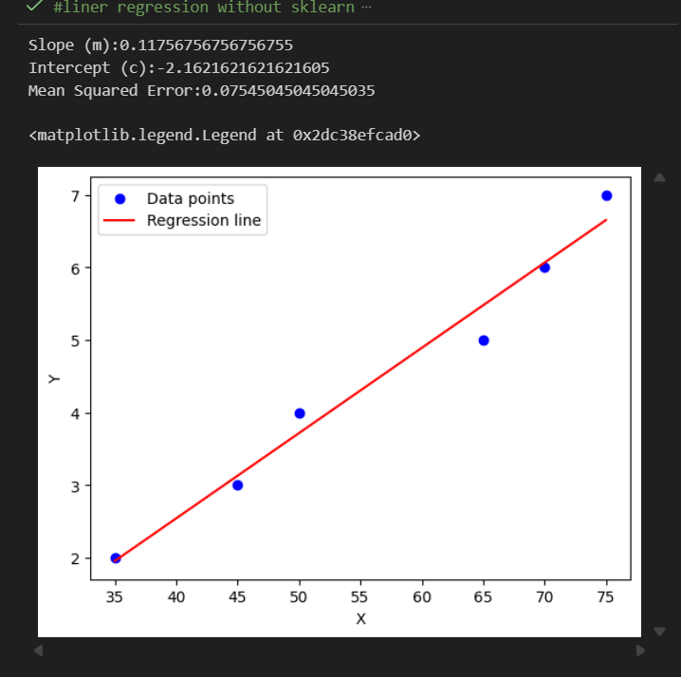

EXP:6- Linear Regression With Sklearn
# Linear regression with sklearn
import numpy as np
import matplotlib.pyplot as plt
from sklearn.linear_model import LinearRegression
from sklearn.metrics import mean_squared_error

x=np.array([35,45,50,65,70,75],dtype=float).reshape(-1,1)
y=np.array([2,3,4,5,6,7],dtype=float)

model=LinearRegression()
model.fit(x, y)

m=model.coef_[0]
c=model.intercept_

print(f"Slope (m):{m}")
print(f"Intercept (c):{c}")

yp=model.predict(x)

mse=mean_squared_error(y, yp)
print(f"Mean Squared Error: {mse}")

plt.scatter(x, y, color='blue', label='Data points')
plt.plot(x, yp, color='red', label='Regression line')
plt.xlabel('X')
plt.ylabel('Y')
plt.title('Linear Regression with sklearn')
plt.legend()
plt.show()

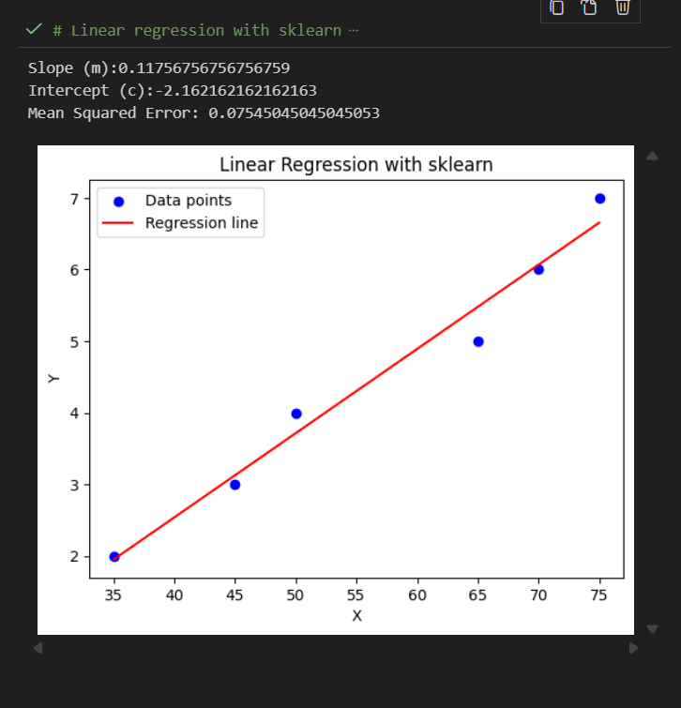

EXP:7- Matplotlib Plotting Techniques
import matplotlib.pyplot as plt

x=[1,2,3,4,5]
y=[10,60,30,40,50]
plt.plot(x,y)
plt.title("Simple Line Graph")
plt.show()

plt.plot(x,y,marker='+',linestyle='--',color='b')
plt.title("Line Graph with + marker,dashed line,blue color")
plt.show()

plt.plot(x,y,marker='o',linestyle='-',color='g')
plt.title("Line Graph with o marker,solid line,green color")
plt.show()
plt.plot(x,y,marker='s',linestyle='-.',color='r')
plt.title("Line Graph with square marker,dash-dot line,red color")
plt.show()

plt.plot(x,y,marker='o',linestyle='--',color='m')
plt.xlabel("X-axis Label")
plt.ylabel("Y-axis Label")
plt.title("Line Graph with Labels and Title")
plt.legend(["Data Series"])
plt.show()

plt.plot(x,y,color='green',linewidth=2,linestyle='-')
plt.xlabel("X-axis")
plt.ylabel("Y-axis")
plt.title("Customized Plot",fontsize=14,color='blue')
plt.xlim(0,6)
plt.ylim(0,60)
plt.grid(color='blue',linestyle='--',linewidth=2)
plt.show()

plt.plot(x, y, label="Line Graph", color='purple')
plt.legend()
plt.title("Line Graph")
plt.show()

plt.bar(x,y,color='skyblue')
plt.title("Bar Chart")
plt.show()

data=[10,20,20,30,40,40,40,50]
plt.hist(data,bins=5,color='orange')
plt.title("Histogram")
plt.show()

plt.scatter(x,y,color='red',marker='x')
plt.title("Scatter Plot")
plt.show()

sizes=[25,35,20,20]
labels=['Category A','Category B','Category C','Category D']

plt.pie(sizes,labels=labels,autopct='%1.1f%%')
plt.title("Pie Chart")
plt.show()

fig,ax=plt.subplots(2,2)

ax[0,0].plot(x,y,color='black')
ax[0,0].set_title("Line Graph")

ax[0,1].bar(x,y,color='blue')
ax[0,1].set_title("Bar Chart")

ax[1,0].scatter(x,y,color='red',marker='x')
ax[1,0].set_title("Scatter Plot")

ax[1,1].pie(sizes,labels=labels,autopct='%1.1f%%')
ax[1,1].set_title("Pie Chart")

plt.tight_layout()
plt.show()

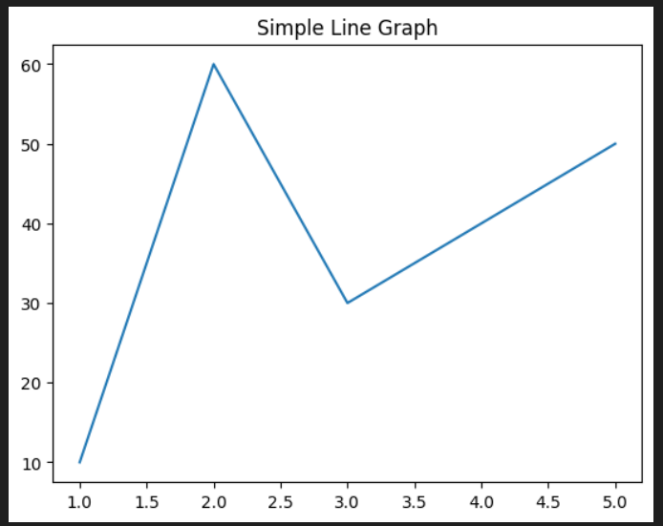
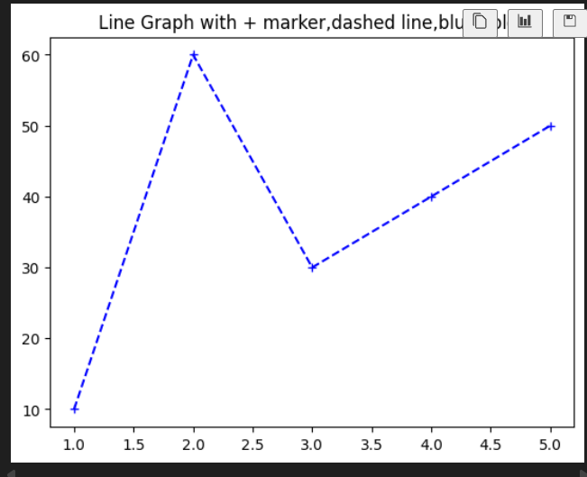
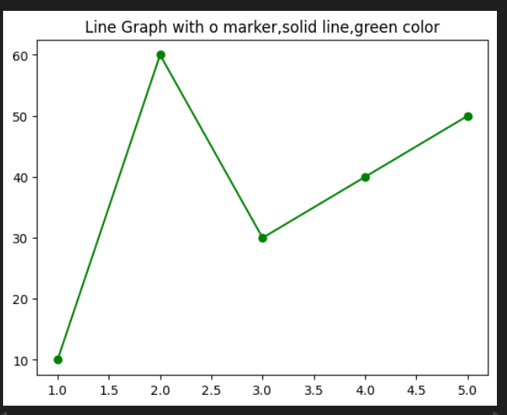
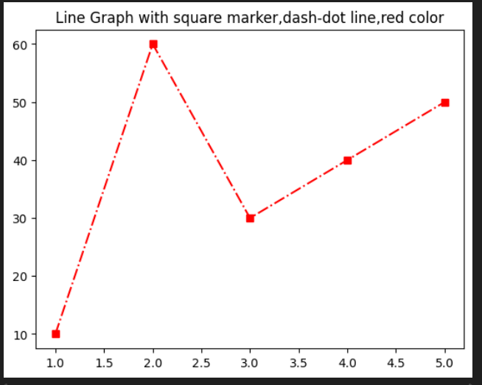
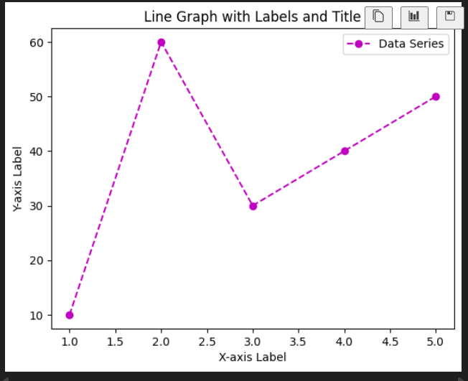
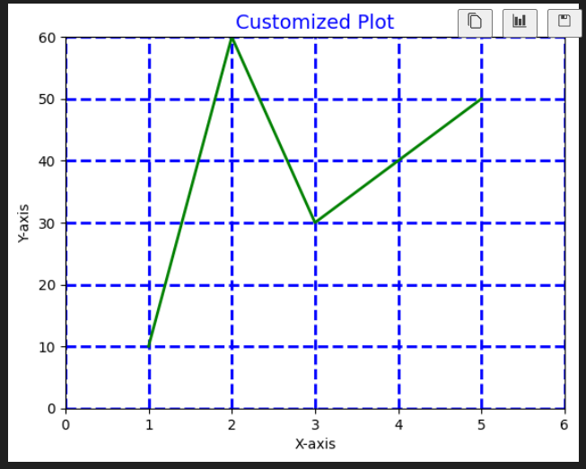
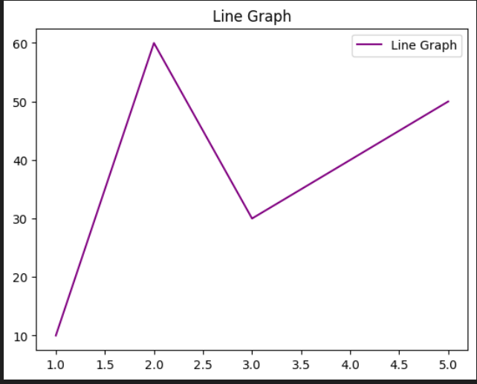
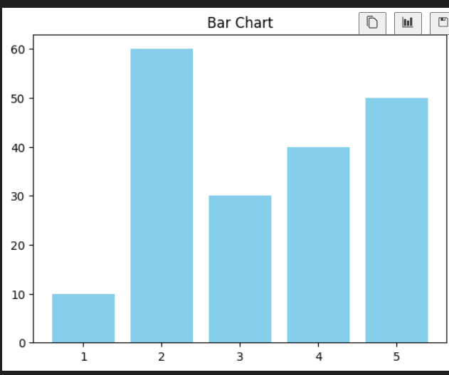
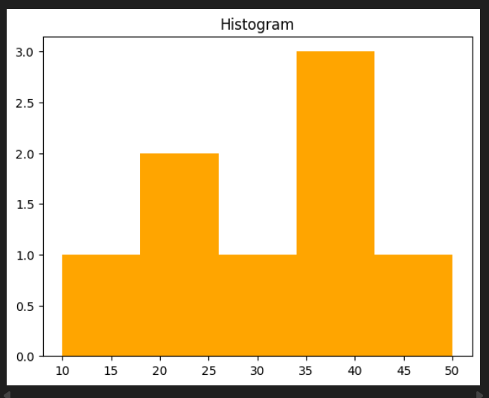
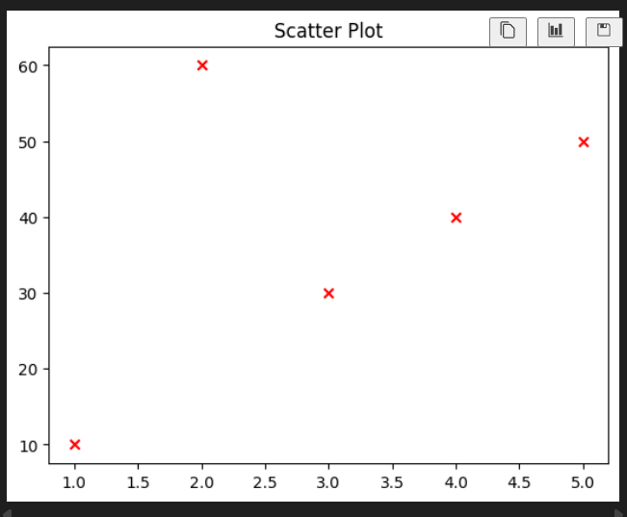

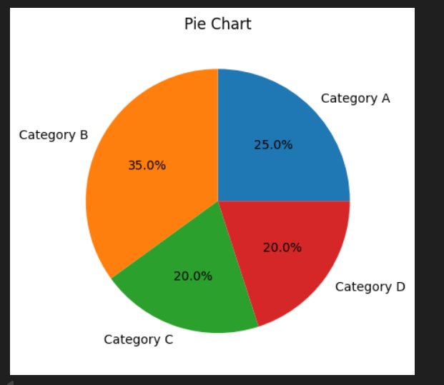
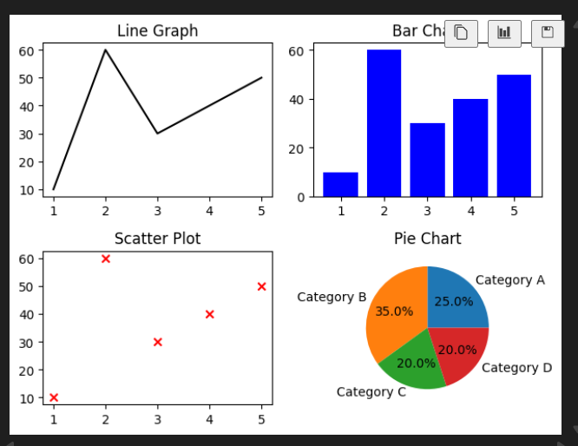

EXP:8- Student Dataset EDA
#EDA
import pandas as pd
import matplotlib.pyplot as plt

file_path="Student Data.xlsx"
df=pd.read_excel(file_path)

cols=["school","sex","age","address","famsize","Medu"]
df=df[cols]

print("First 10 rows:")
print(df.head(10),"\n")

print("Shape(rows,cols):",df.shape,"\n")

print("Missing values per column:")
print(df.isnull().sum(),"\n")

print("Mean:\n",df.mean(numeric_only=True),"\n")
print("Median:\n",df.median(numeric_only=True),"\n")
print("Mode:\n",df.mode().iloc[0],"\n")
print("Standard Deviation:\n",df.std(numeric_only=True),"\n")

print("Max values:\n",df.max(numeric_only=True),"\n")
print("Min values:\n",df.min(numeric_only=True),"\n")

print("Unique values per categorical column:")
print(df.select_dtypes(include=['object']).nunique(),"\n")

df['age'].plot(kind='hist',bins=10,edgecolor='black',title="Age Distribution")
plt.xlabel("Age")
plt.show()

df['sex'].value_counts().plot(kind='bar',title="Sex Frequency")
plt.xlabel("Sex")
plt.ylabel("Count")
plt.show()

plt.scatter(df['age'],df['Medu'])
plt.xlabel("Age")
plt.ylabel("Medu (Mother's Education)")
plt.title("Scatter plot: Age vs Medu")
plt.show()

df['age'].plot(kind='box',title="Boxplot of Age")
plt.show()

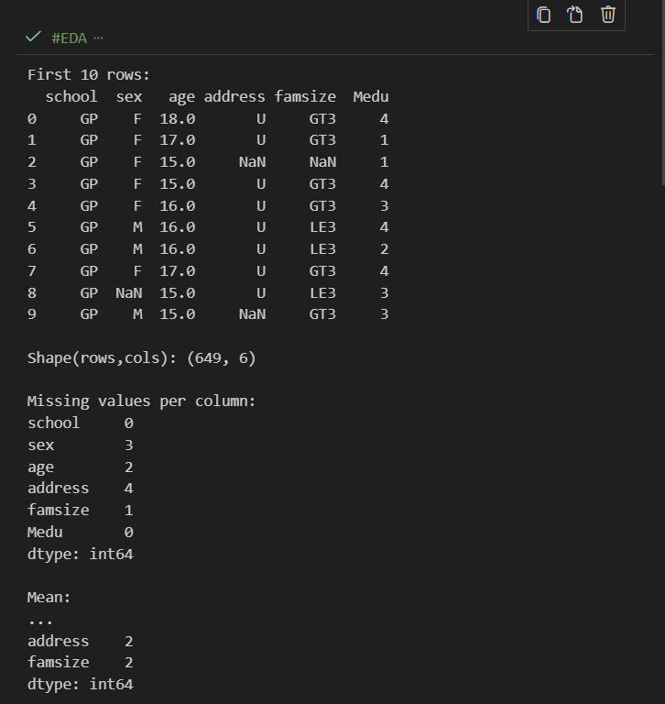
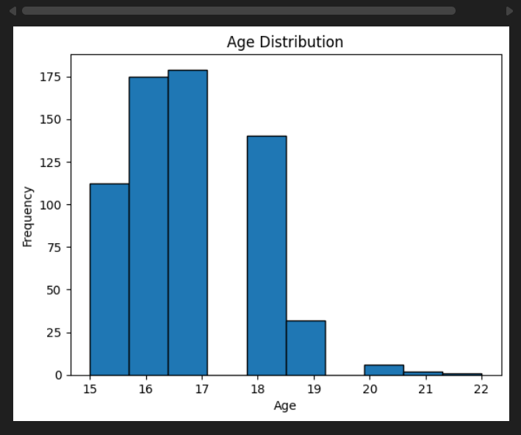
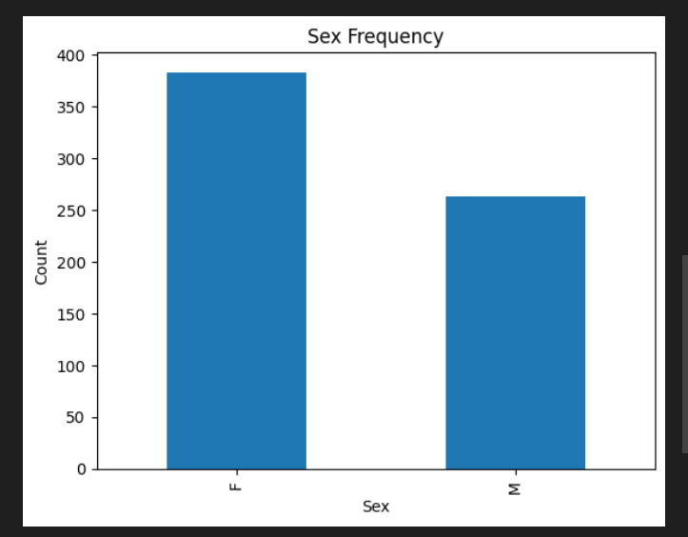
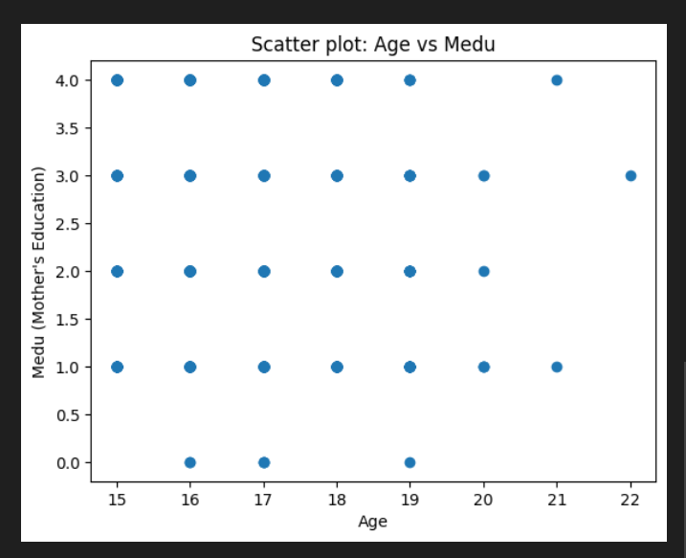
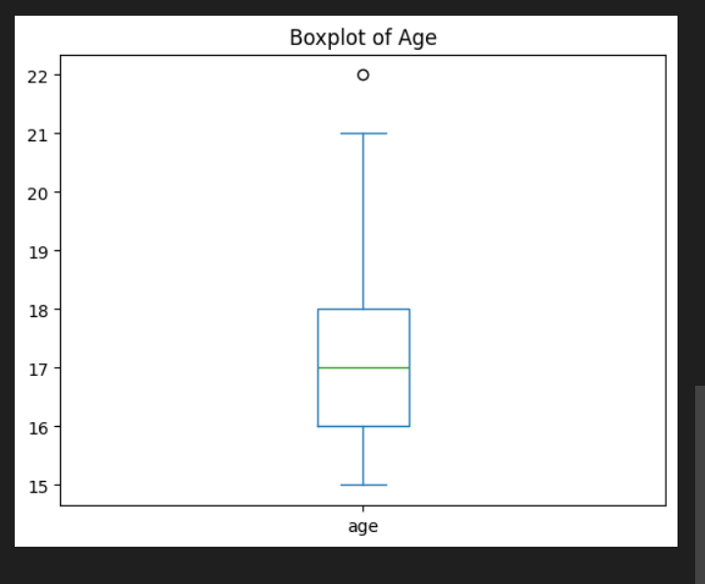

EXP:9- Z-Score Outlier Detection
import pandas as pd
import numpy as np

file_path="Student Data.xlsx"
df=pd.read_excel(file_path)

num_cols=df.select_dtypes(include=['number']).columns

z=(df[num_cols]-df[num_cols].mean())/df[num_cols].std()

threshold=2

outliers_colwise={}

for col in num_cols:
mask=np.abs(z[col])>threshold
outliers_colwise[col]=df.loc[mask,[col]]

for col,vals in outliers_colwise.items():
print(f"\n{col}:{len(vals)} outliers")
if len(vals)>0:
print(vals.to_string(index=False))
else:
print("No outliers detected.")

age:9 outliers
age
22.0
20.0
20.0
21.0
21.0
20.0
20.0
20.0
20.0

Medu:6 outliers
Medu
0
0
0
0
0
0

Fedu:7 outliers
Fedu
0
0
0
0
0
0
0

traveltime:16 outliers
traveltime
4
4
4
4
4
4
4
4
4
4
4
4
4
4
4
4

studytime:35 outliers
studytime
4
4
4
4
4
4
4
4
4
4
4
4
4
4
4
4
4
4
4
4
4
4
4
4
4
4
4
4
4
4
4
4
4
4
4

failures:30 outliers
failures
3
3
2
3
2
2
3
3
2
2
3
3
3
2
2
2
2
2
3
2
3
2
3
3
2
3
2
2
2
3

famrel:51 outliers
famrel
1
2
2
2
2
1
2
1
2
1
2
2
2
2
1
2
1
2
2
2
1
2
2
1
1
2
1
1
1
1
1
2
1
2
1
2
2
2
1
1
2
2
2
1
2
2
1
1
2
1
2

freetime:45 outliers
freetime
1
1
1
1
1
1
1
1
1
1
1
1
1
1
1
1
1
1
1
1
1
1
1
1
1
1
1
1
1
1
1
1
1
1
1
1
1
1
1
1
1
1
1
1
1

goout:0 outliers
No outliers detected.

Dalc:34 outliers
Dalc
5
4
5
5
5
4
5
4
4
4
4
5
4
5
5
4
4
4
5
5
4
4
4
5
5
4
4
5
5
5
5
5
4
4

Walc:45 outliers
Walc
5
5
5
5
5
5
5
5
5
5
5
5
5
5
5
5
5
5
5
5
5
5
5
5
5
5
5
5
5
5
5
5
5
5
5
5
5
5
5
5
5
5
5
5
5

health:0 outliers
No outliers detected.

absences:32 outliers
absences
16
14
14
16
14
24
22
16
14
32
16
16
30
21
14
15
16
18
16
14
26
14
16
16
15
22
18
14
18
16
21
13

G1:32 outliers
G1
0
17
17
17
18
17
17
17
17
18
17
17
18
18
18
17
17
17
5
17
4
4
5
18
17
17
5
5
18
19
17
5

G2:25 outliers
G2
18
18
18
18
19
18
18
18
18
18
0
5
18
0
0
5
18
18
0
0
0
18
0
5
18

G3:19 outliers
G3
0
1
5
19
0
0
0
0
0
0
0
0
0
0
0
19
0
0
0

EXP:10- One-Hot Encoding & List Merge
import pandas as pd

file=r"e:\sem 3\aiml lab\data2.xlsx"
df=pd.read_excel(file)

print("\nOriginal Data:")
print(df)

cols=df.select_dtypes(include=['object']).columns
print("\nCategorical columns detected:",list(cols))

enc=pd.get_dummies(df,columns=cols,dtype=int)

for col in cols:
enc.columns=[c.replace(f"{col}_","") for c in enc.columns]

future_cols=[c for c in enc.columns if c in df['Future Dream'].unique()]
enc['Future Dream']=enc[future_cols].apply(lambda x:x.tolist(),axis=1)

difficulty_cols=[c for c in enc.columns if c in df['Label'].unique()]
enc['Difficulty']=enc[difficulty_cols].apply(lambda x:x.tolist(),axis=1)

print("\nEncoded Data with Future Dream and Difficulty Lists:")
print(enc)

out_file="encoded_output.xlsx"
enc.to_excel(out_file,index=False)
print(f"\nOne-hot encoded data saved to: {out_file}")

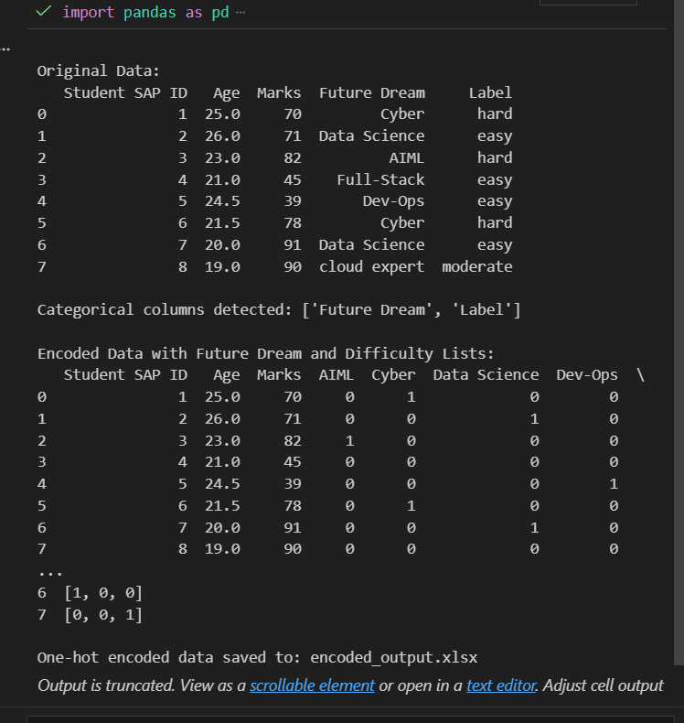

EXP:11.1- PCA Using Sklearn
import numpy as np
import pandas as pd
from sklearn.decomposition import PCA
from sklearn.preprocessing import StandardScaler

data=np.array([[2,3],[3,4],[4,5],[5,6]])
df=pd.DataFrame(data,columns=['X','Y'])
print("Original Data:\n",df)

sc=StandardScaler()
X_sc=sc.fit_transform(df)

pca=PCA(n_components=2)
pca.fit(X_sc)
X_pca=pca.transform(X_sc)

print("\nPrincipal Axes (Components):\n",pca.components_)
print("\nExplained Variance Ratio:", pca.explained_variance_ratio_)
print("\nProjection of each point along first principal axis:\n", X_pca)

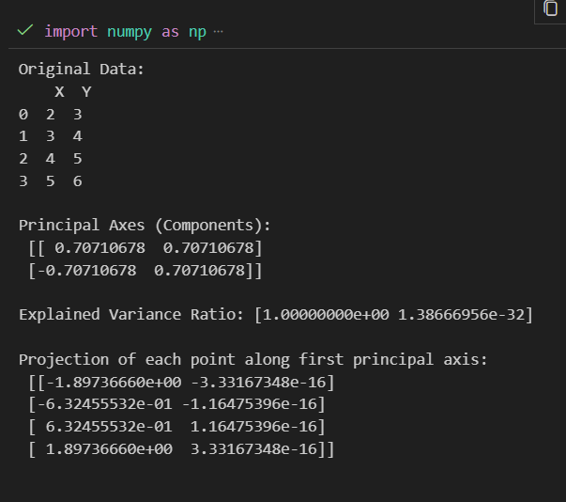

EXP:11.2- PCA Without Sklearn
import numpy as np
import pandas as pd

data=np.array([[2,3],[3,4],[4,5],[5,6]])
df=pd.DataFrame(data,columns=['X','Y'])
print("Original Data:\n",df)

X_mean=np.mean(data,axis=0)
X_std=np.std(data,axis=0)
X_sc=(data-X_mean)/X_std
print("\nStandardized Data:\n",X_sc)

cov_mat=np.cov(X_sc.T)
print("\nCovariance Matrix:\n",cov_mat)

eig_vals,eig_vecs=np.linalg.eig(cov_mat)
print("\nEigenvalues:\n",eig_vals)
print("\nEigenvectors (Principal Axes):\n",eig_vecs)

idx=np.argsort(eig_vals)[::-1]
eig_vals=eig_vals[idx]
eig_vecs=eig_vecs[:,idx]

first_axis=eig_vecs[:,0]
projection=np.dot(X_sc,first_axis)
print("\nProjection along first principal axis:\n",projection)

var_exp=eig_vals/np.sum(eig_vals)
print("\nExplained Variance Ratio:\n",var_exp)

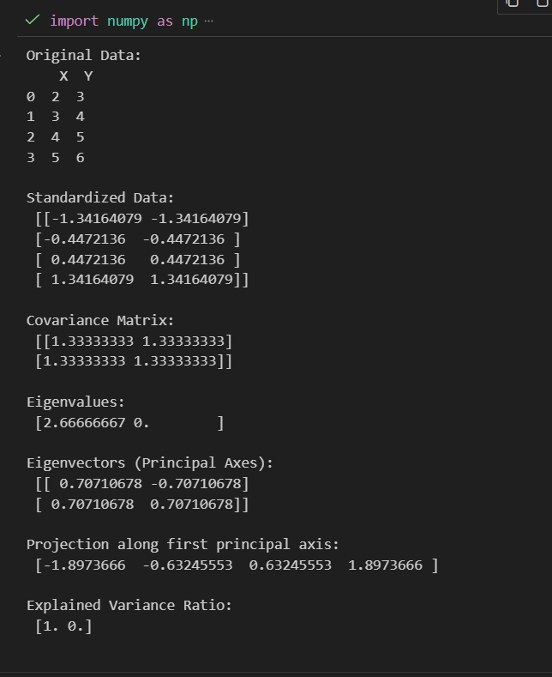

EXP:12- Logistic Regression on Credit Fraud
import pandas as pd
from sklearn.model_selection import train_test_split
from sklearn.linear_model import LogisticRegression
from sklearn.metrics import accuracy_score, precision_score, recall_score, f1_score

f=r"e:\sem 3\aiml lab\creditcard.csv"
df=pd.read_csv(f)
print("Data loaded:",df.shape)

n=df['Class'].nunique()
print("No. of classes:",n)

c=df['Class'].value_counts()
print("Samples per class:\n",c)

if c.nunique()!=1:
print("Unbalanced...balancing")
maj=df[df['Class']==c.idxmax()]
mino=df[df['Class']==c.idxmin()]
mino_up=mino.sample(len(maj),replace=True,random_state=0)
dfb=pd.concat([maj,mino_up],axis=0).sample(frac=1,random_state=0)
print("Balanced counts:\n",dfb['Class'].value_counts())
else:
print("Already balanced")

dfb.to_csv("balanced_creditcard.csv",index=False)
print("Saved: balanced_creditcard.csv")

x=dfb.drop('Class',axis=1)
y=dfb['Class']
xtr,xts,ytr,yts=train_test_split(x,y,test_size=0.3,random_state=0)

ep=10
r=[]
for i in range(ep):
it=(i+1)*50
m=LogisticRegression(max_iter=it,solver='lbfgs')
m.fit(xtr,ytr)
yp=m.predict(xts)
acc=accuracy_score(yts,yp)
pre=precision_score(yts,yp)
rec=recall_score(yts,yp)
f1=f1_score(yts,yp)
r.append([i+1,it,acc,pre,rec,f1])

res=pd.DataFrame(r,columns=['Epoch','Iter','Accuracy','Precision','Recall','F1'])
print("\nResults:\n",res)

best=res.loc[res['F1'].idxmax()]
print(f"\nBest Epoch: {int(best['Epoch'])} | Acc={best['Accuracy']:.4f} | Pre={best['Precision']:.4f} | Rec={best['Recall']:.4f} | F1={best['F1']:.4f}")

Data loaded: (284807, 31)
No. of classes: 2
Samples per class:
Class
0 284315
1 492
Name: count, dtype: int64
Unbalanced...balancing
Balanced counts:
Class
1 284315
0 284315
Name: count, dtype: int64
Saved: balanced_creditcard.csv
STOP: TOTAL NO. of ITERATIONS REACHED LIMIT.

STOP: TOTAL NO. of ITERATIONS REACHED LIMIT.

STOP: TOTAL NO. of ITERATIONS REACHED LIMIT.

STOP: TOTAL NO. of ITERATIONS REACHED LIMIT.

STOP: TOTAL NO. of ITERATIONS REACHED LIMIT.

STOP: TOTAL NO. of ITERATIONS REACHED LIMIT.

STOP: TOTAL NO. of ITERATIONS REACHED LIMIT.

STOP: TOTAL NO. of ITERATIONS REACHED LIMIT.

STOP: TOTAL NO. of ITERATIONS REACHED LIMIT.

Results:
Epoch Iter Accuracy Precision Recall F1
0 1 50 0.917855 0.951327 0.880333 0.914454
1 2 100 0.945647 0.964577 0.924986 0.944367
2 3 150 0.944944 0.963161 0.924986 0.943688
3 4 200 0.944920 0.967000 0.920990 0.943434
4 5 250 0.949293 0.969933 0.927067 0.948016
5 6 300 0.949282 0.969909 0.927067 0.948004
6 7 350 0.948924 0.971081 0.925139 0.947553
7 8 400 0.948953 0.971141 0.925139 0.947582
8 9 450 0.948930 0.971093 0.925139 0.947559
9 10 500 0.948889 0.971009 0.925139 0.947519

Best Epoch: 5 | Acc=0.9493 | Pre=0.9699 | Rec=0.9271 | F1=0.9480
STOP: TOTAL NO. of ITERATIONS REACHED LIMIT.

